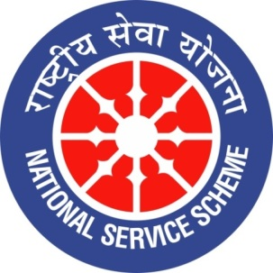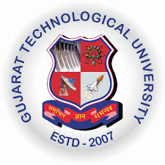
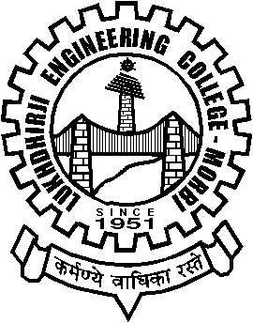
GUJARAT TECHNOLOGY UNIVERSITY
NATIONAL SERVICE SCHEME
Lukhdhirji Engineering College-Morbi
A Report on Rastriya Ekta Divas Pledge on 30/10/21 of L.E.College-Morbi

NSS Unit Name/College Name: L.E.College-Morbi
Event NAME: Rastriya Ekta Divas Pledge
Event Date, Time and Location: 11:00 am, In front of A-block
Brief Description of the Event:
31st October , birthday of Iron man sardar patel, is celebrated as rastriya ekta divas. As per instruction of Home ministry f India Rastriya Ekta Divas pledge need to be taken. As a part of Azadi ka amrut mahotsav and as per instruction given by CTE, staff members have taken pledge in front of A-block along with banner. Total 63 staff members have taken pledge. To maintain covid-19 protocal it was taken in various groups.
Major Outcomes of Event:
Foster and reinforce our dedication to preserve and strengthen unity, integrity and security of India.
Photographs of the Event:

